**PMWebSpec AWS Setup User Guide**

**Application Introduction –**

PMWebSpec is a Web Based Application developed using CodeIgniter based PHP Programming language (Version 5.5 – 7.4). Frontend is developed in HTML5, CSS, JavaScript, Bootstrap and MySQL as database.

**Application Architecture –**

**Backend** - PHP CodeIgniter (MVC Structure)

**Database** – MySQL

**Frontend Tech** – HTML5, JavaScript, CSS, Bootstrap

**Software Required –**

*Note: - The installation steps are specific to AWS and may differ for other Cloud platforms.*

## **AWS Setup –**

* MYSQL Workbench – Database setup
* AWS Account for setup application on AWS Cloud

1. **Creating an Elastic Beanstalk environment**

**To launch an environment with a sample application (console)**

1. Open the [Elastic Beanstalk console](https://docs.aws.amazon.com/elasticbeanstalk/latest/dg/applications.html), and in the **Regions** list, select your AWS Region.
2. In the navigation pane, choose **Applications**, and then choose an existing application's name in the list or [create one](https://console.aws.amazon.com/elasticbeanstalk).
3. On the application overview page, choose **Create a new environment**.

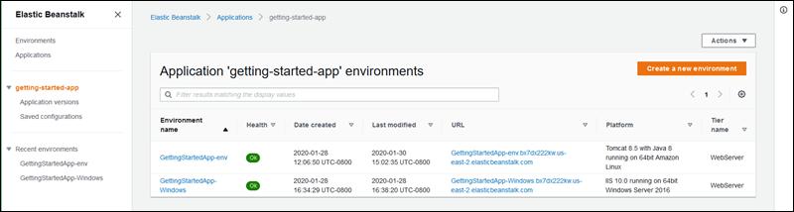

1. Next, for environment tier, choose the **Web server environment** **environment** [environment tier](https://docs.aws.amazon.com/elasticbeanstalk/latest/dg/concepts.html" \l "concepts-tier). You can't change an environment's tier after creation.

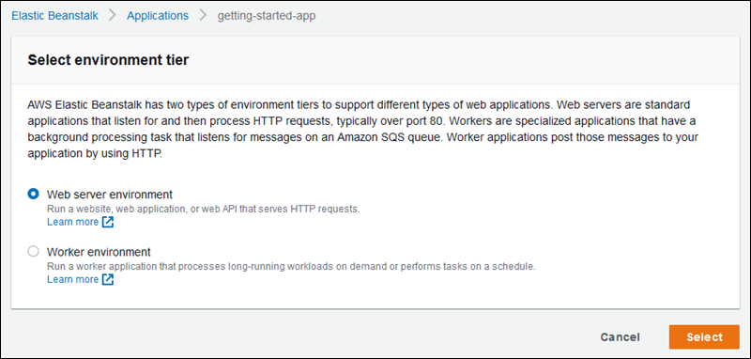

1. Under **Platform**, select “PHP 7.4 running on 64bit Amazon Linux 2”.

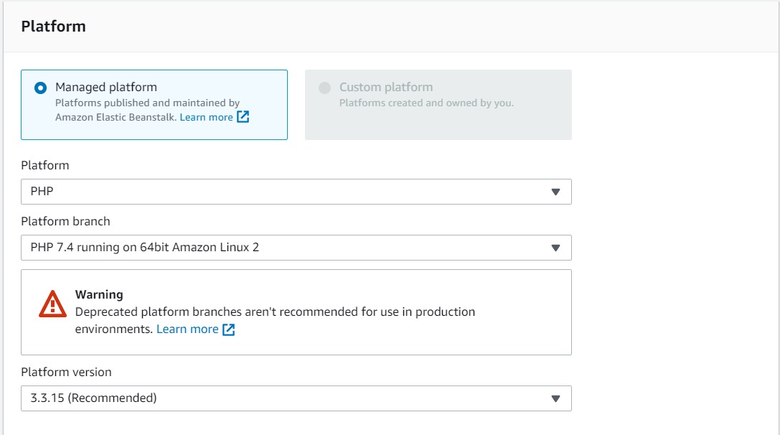

1. For **Application code**, choose **Sample application**.

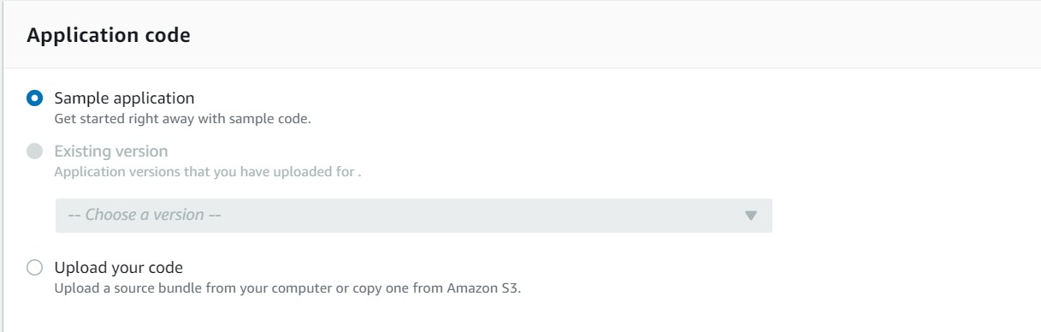

1. Select the following options for **Load balancer, Instance, Database** settings and hit **Save**:

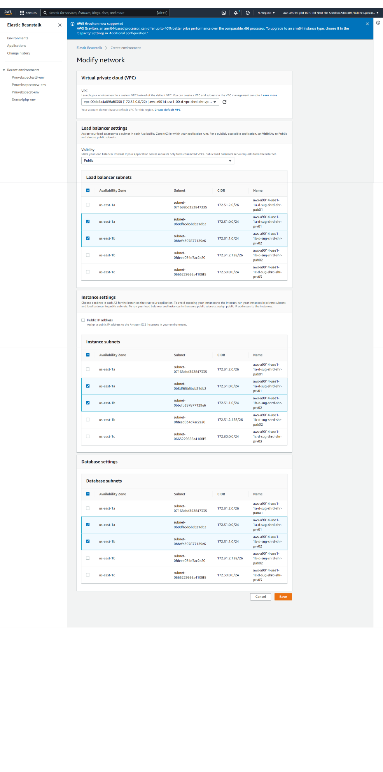

1. Hit “**Create environment”**.

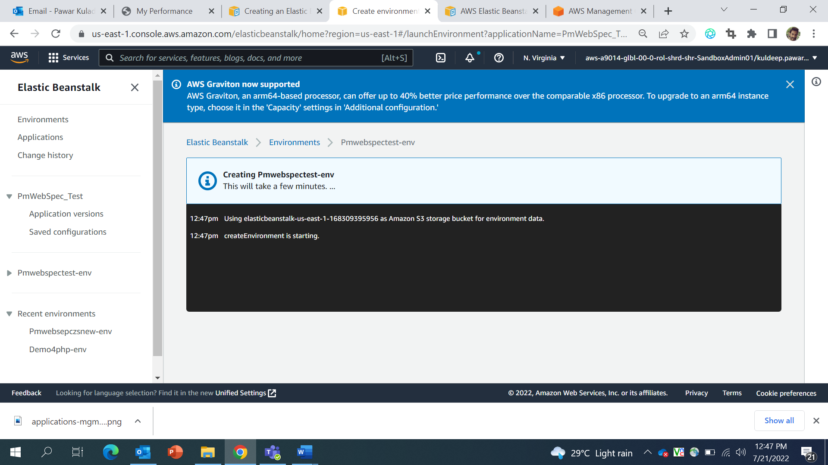

**Configuration setting for creating elastic beanstalk instance for PMWebSpec.**

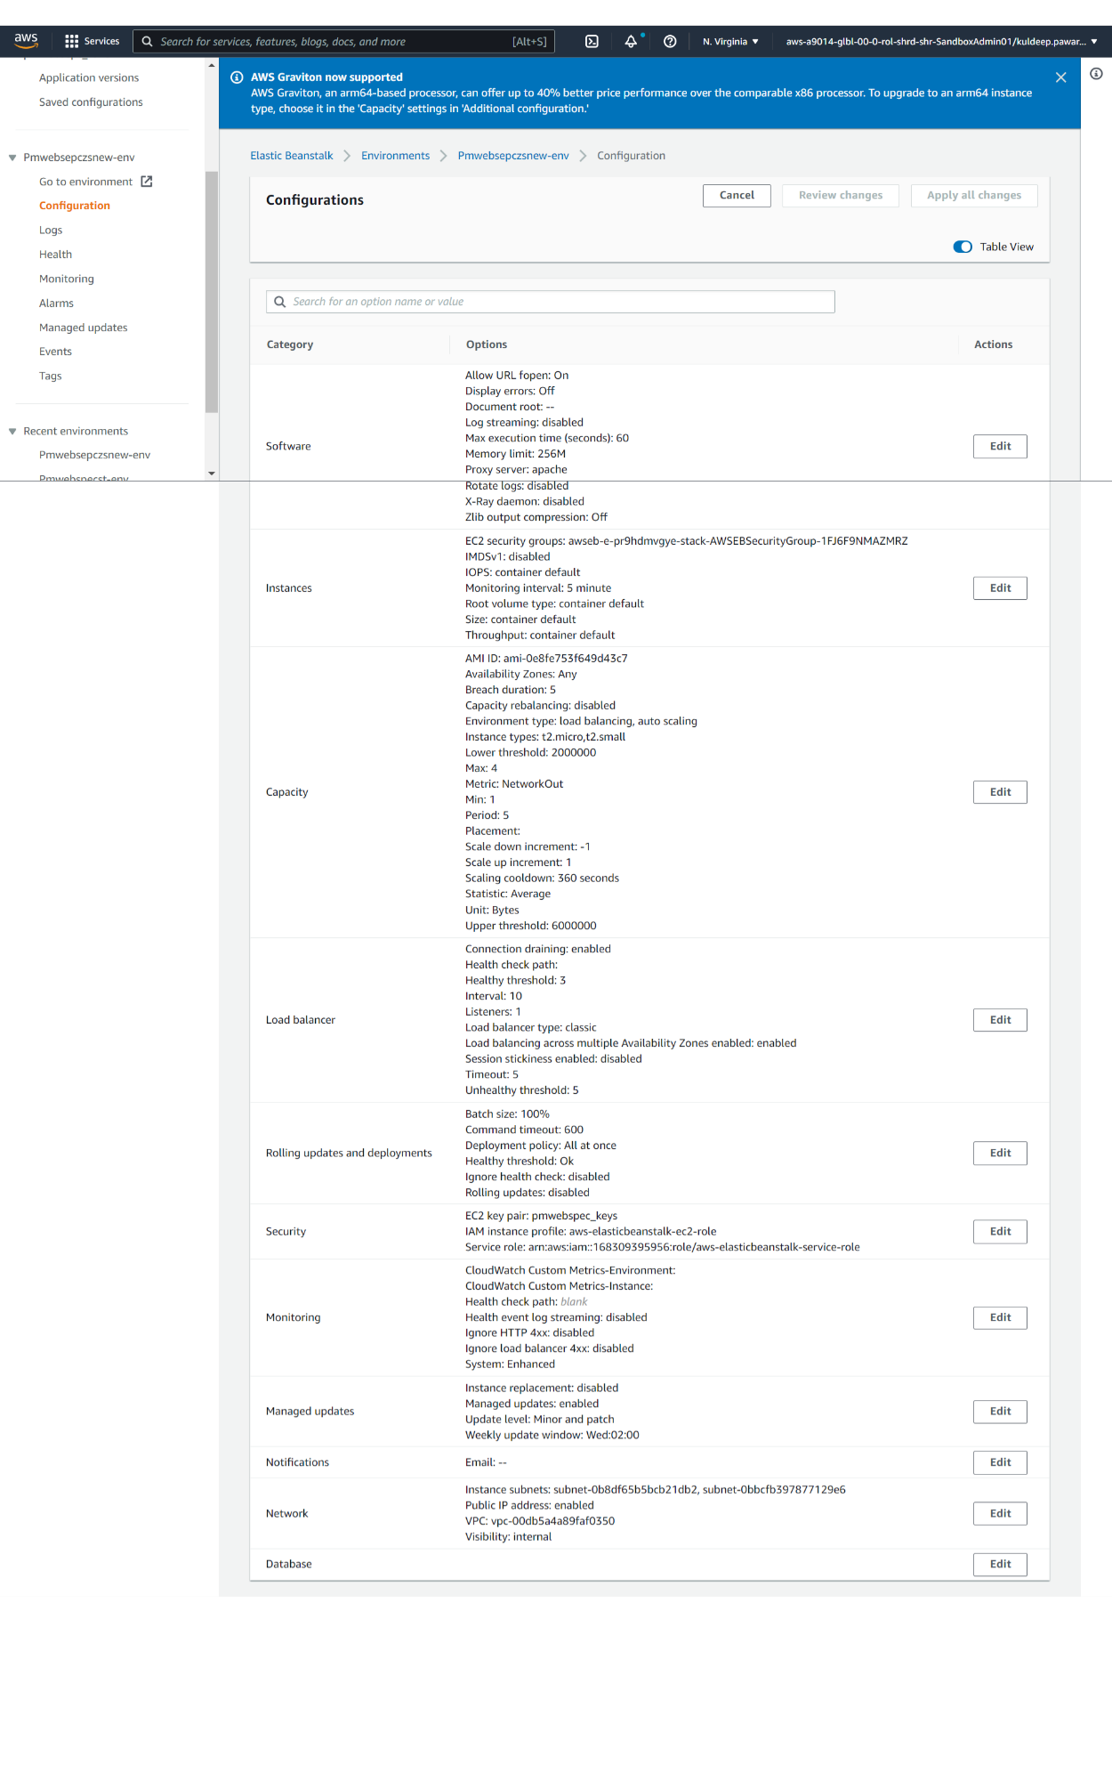

1. **Deploying a new version of the application**

Periodically, you might need to deploy a new version of your application. You can deploy a new version at any time, as long as no other update operations are in progress on your environment.

To update your application version

* 1. Download the zip file of the PMWebSpec Application code from **https://github.com/BMS-CPP/PmWebSpec_Test/tree/main/PmWebSpec_dev**
  2. Navigate to Elastic Beanstalk > Environment > “Application Name” and select “**upload and deploy”**. 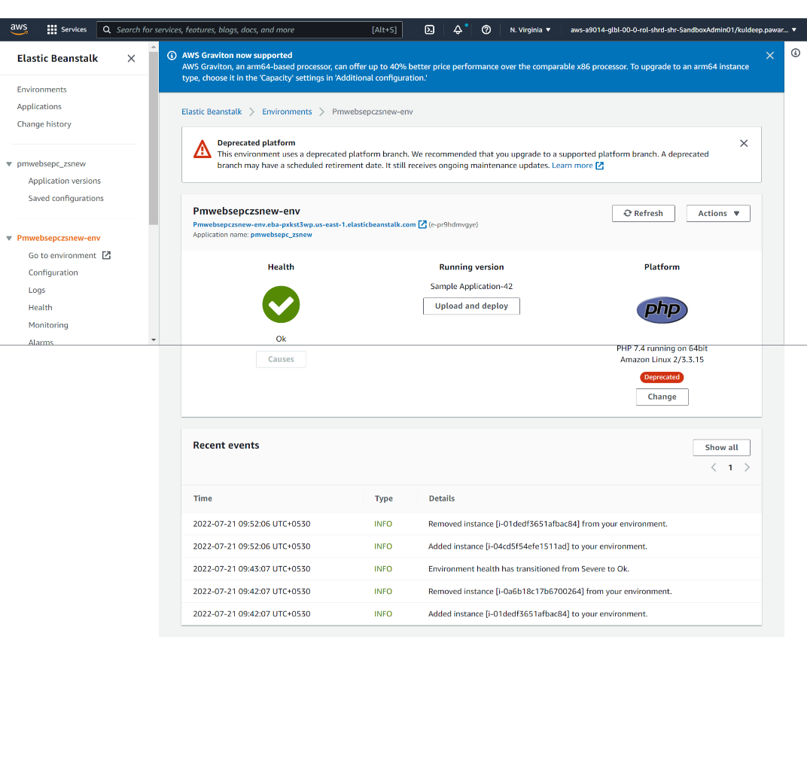
  3. Upload the application zip file that you just downloaded. And select **Deploy.**

Note: The console automatically fills in the Version label with a new unique label. If you type in your own version label, ensure that it's unique.

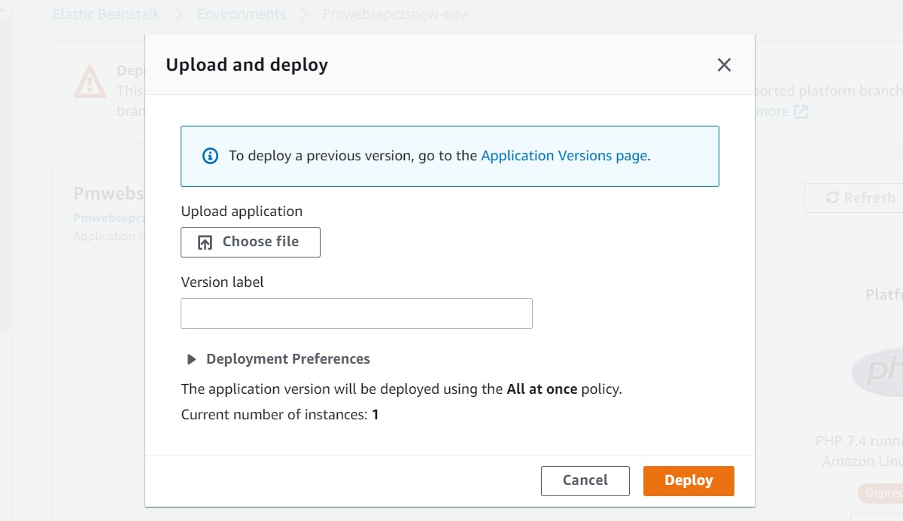

1. **Creating an Amazon RDS DB instance**

The basic building block of Amazon RDS is the DB instance, where you create your databases. You choose the engine-specific characteristics of the DB instance when you create it. You also choose the storage capacity, CPU, memory, and so on, of the AWS instance on which the database server runs.

**To create a DB instance**

1. Sign into the AWS Management Console and open the Amazon RDS console at <https://console.aws.amazon.com/rds/>.
2. In the upper-right corner of the Amazon RDS console, choose the AWS Region in which you want to create the DB instance.
3. In the navigation pane, choose **Databases**.
4. Choose **Create database**.
5. In **Choose a database creation method**, select **Standard Create**.
6. In **Engine options**, choose **MySQL**

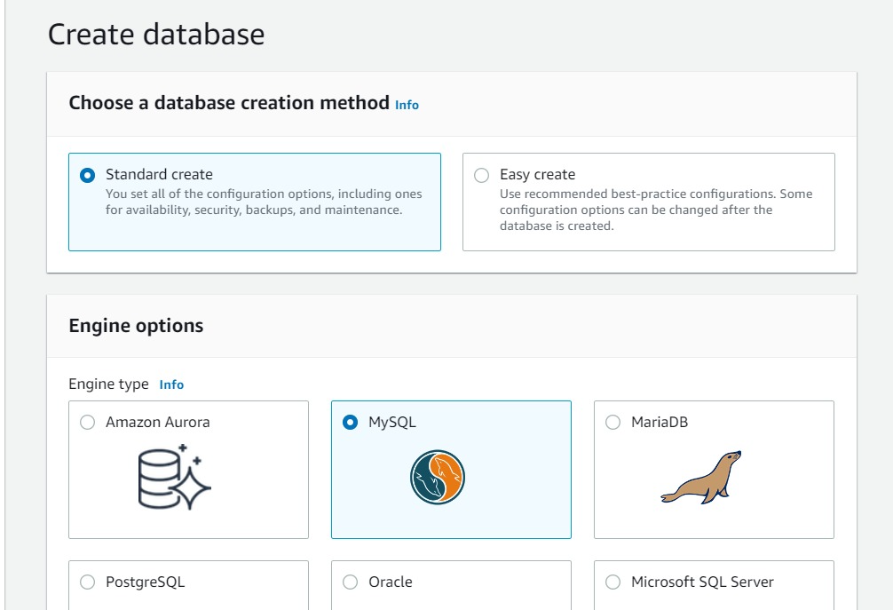

1. For **Version**, choose the engine version.
2. In **Templates**, choose the template that matches your use case. For PMWebSpec we are using **Dev/Test Template**

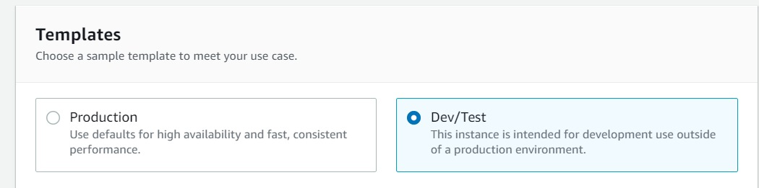

1. To enter your master password, do the following:
   * In the **Settings** section, open **Credential Settings**.
   * If you want to specify a password, clear the **Auto generate a password** check box if it is selected.
   * (Optional) Change the **Master username** value.
   * Enter the same password in **Master password** and **Confirm password**.

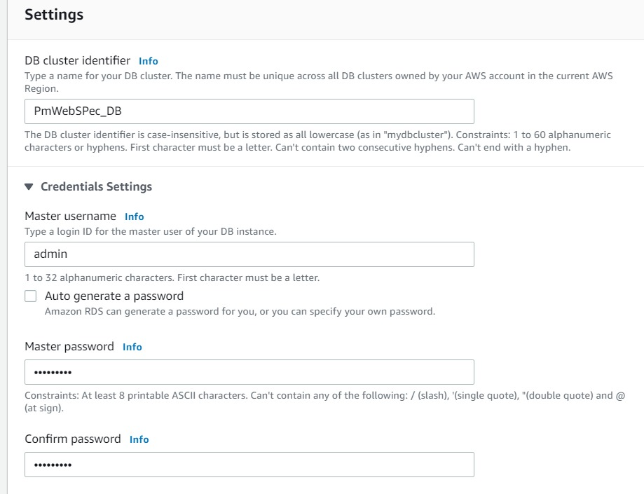

1. For the remaining sections, specify your DB instance settings.
2. Select **Create database**.

Note: If you chose to use an automatically generated password, the **View credential details** button appears on the **Databases** page.To view the master username and password for the DB instance, choose **View credential details**.



To connect to the DB instance as the master user, use the username and password that appear.

1. For **Databases**, choose the name of the new DB instance.

On the RDS console, the details for the new DB instance appear. The DB instance has a status of **Creating** until the DB instance is created and ready for use. When the state changes to **Available**, you can connect to the DB instance. Depending on the DB instance class and storage allocated, it can take several minutes for the new instance to be available.

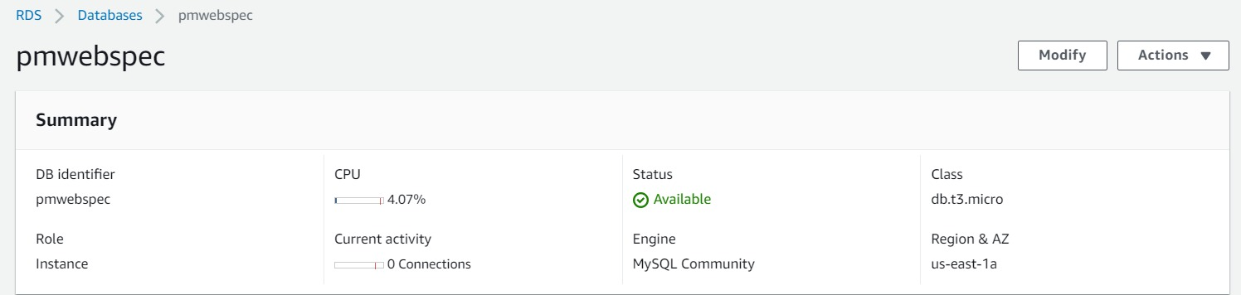

1. **Database Migration**

For PMWebSpec we are using two database **dbstrcut_ci_test** and **web_based_spec_ci_test** for connectivity to application we need to connect application to RDS Instance.

1. For database setup we require MYSQL workbench software. To install SQL workbench, visit: https://dev.mysql.com/downloads/workbench/ 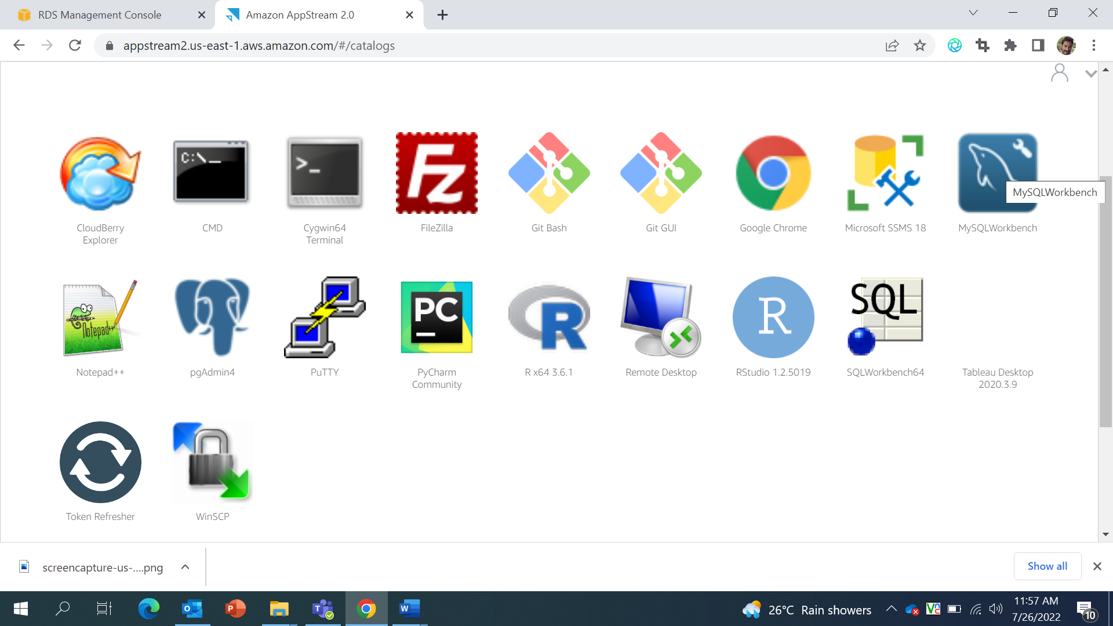
2. Open MYSQL workbench 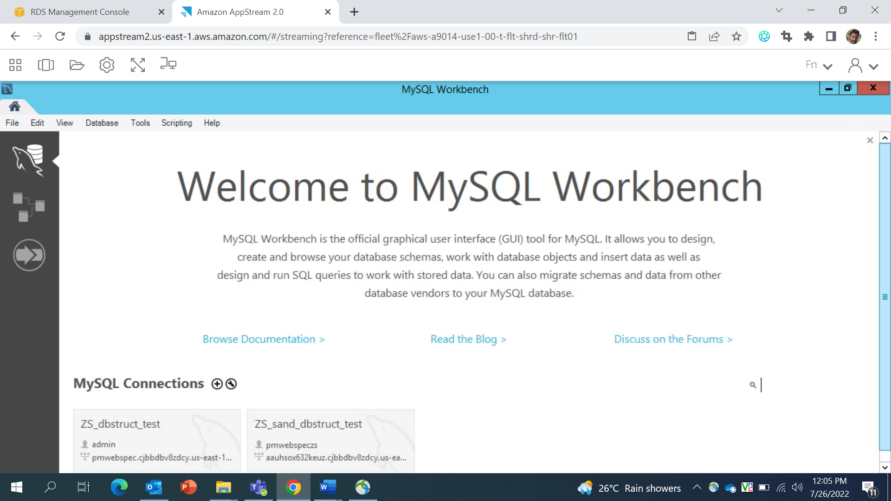
3. Click on “Database” from navigation bar and select manage connection from the dropdown. 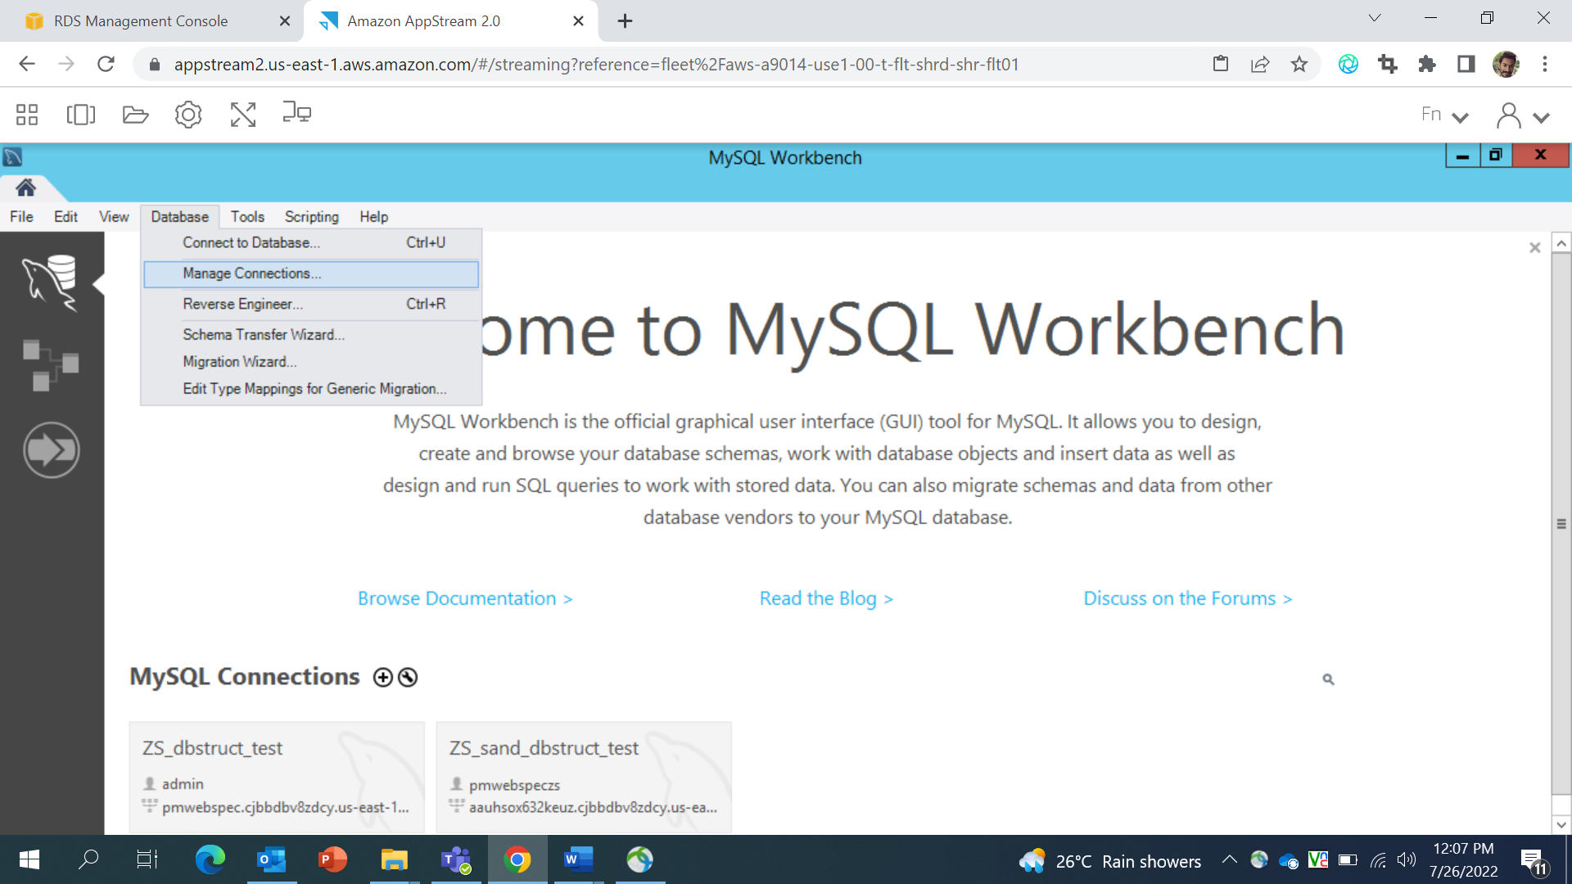
4. You will redirect to the new manage connection popup – 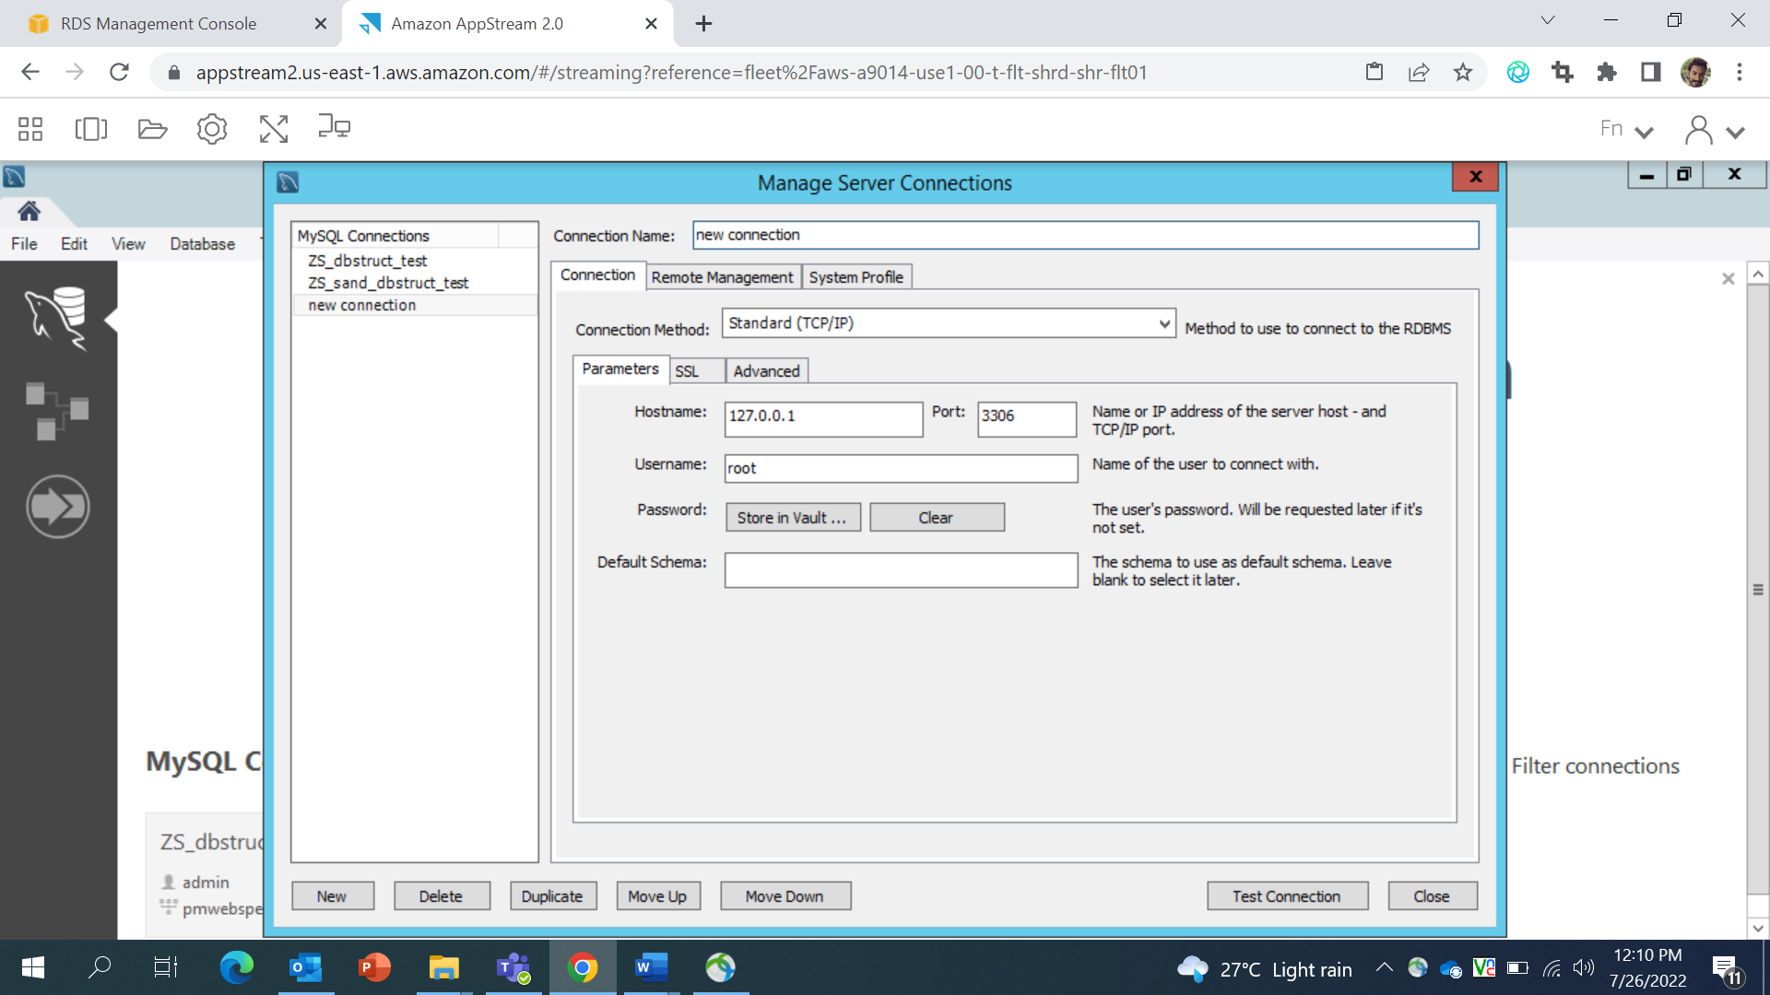

click on the “New” button from left bottom popup to create new connection and provide all the connectivity details into the form. fill in the **Hostname, Port, Username and Password** (Note: Hostname will be endpoint Name you can find it on RDS Details page refer **step6** and username and password will be same that we are using at the time of Database creation refer **step 5**).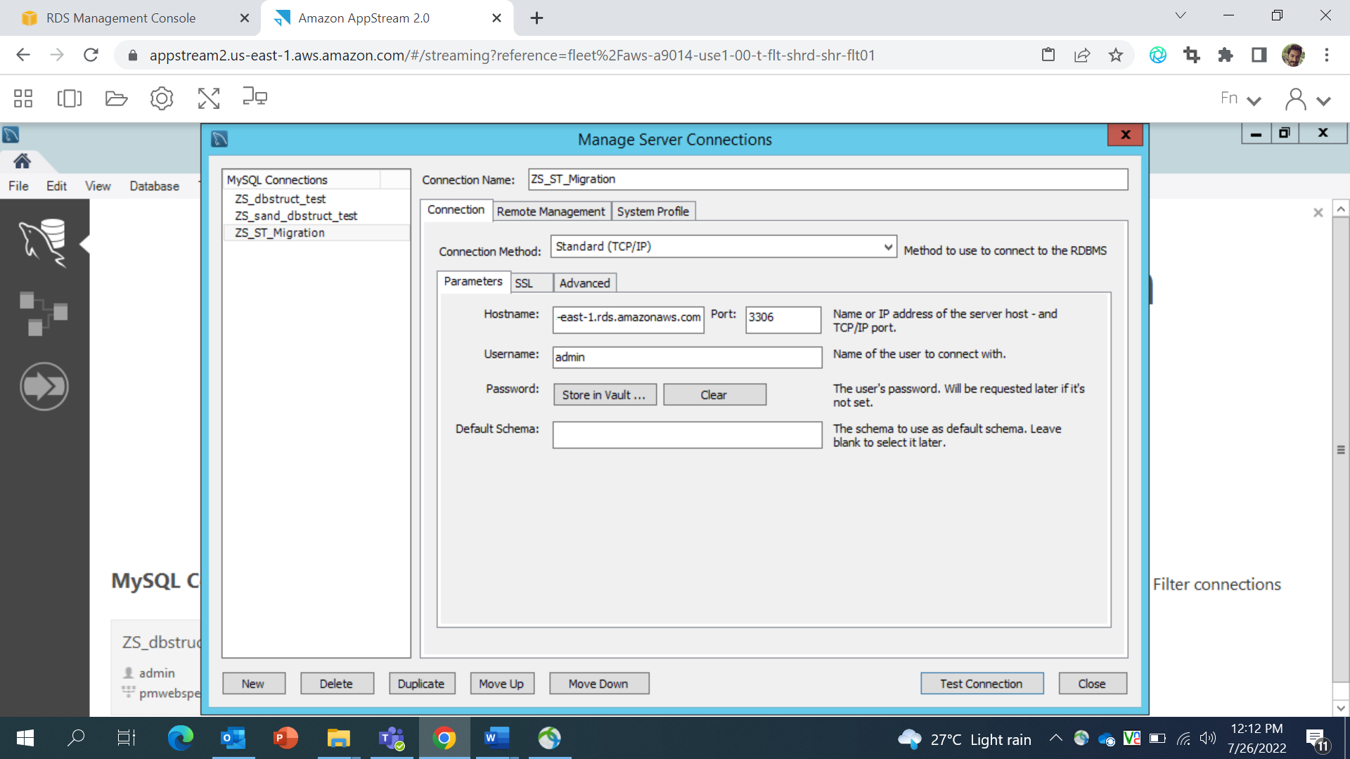 Click on Store in vault it will redirect to password window we need to enter password for database.

1. click on the “New” button from left bottom popup to create new connection and provide all the connectivity details into the form.
2. Test connection is successful or not, if connection is successful then close the window.
3. Go to the top navigation bar and click on “Database” button and select connect database from dropdown. 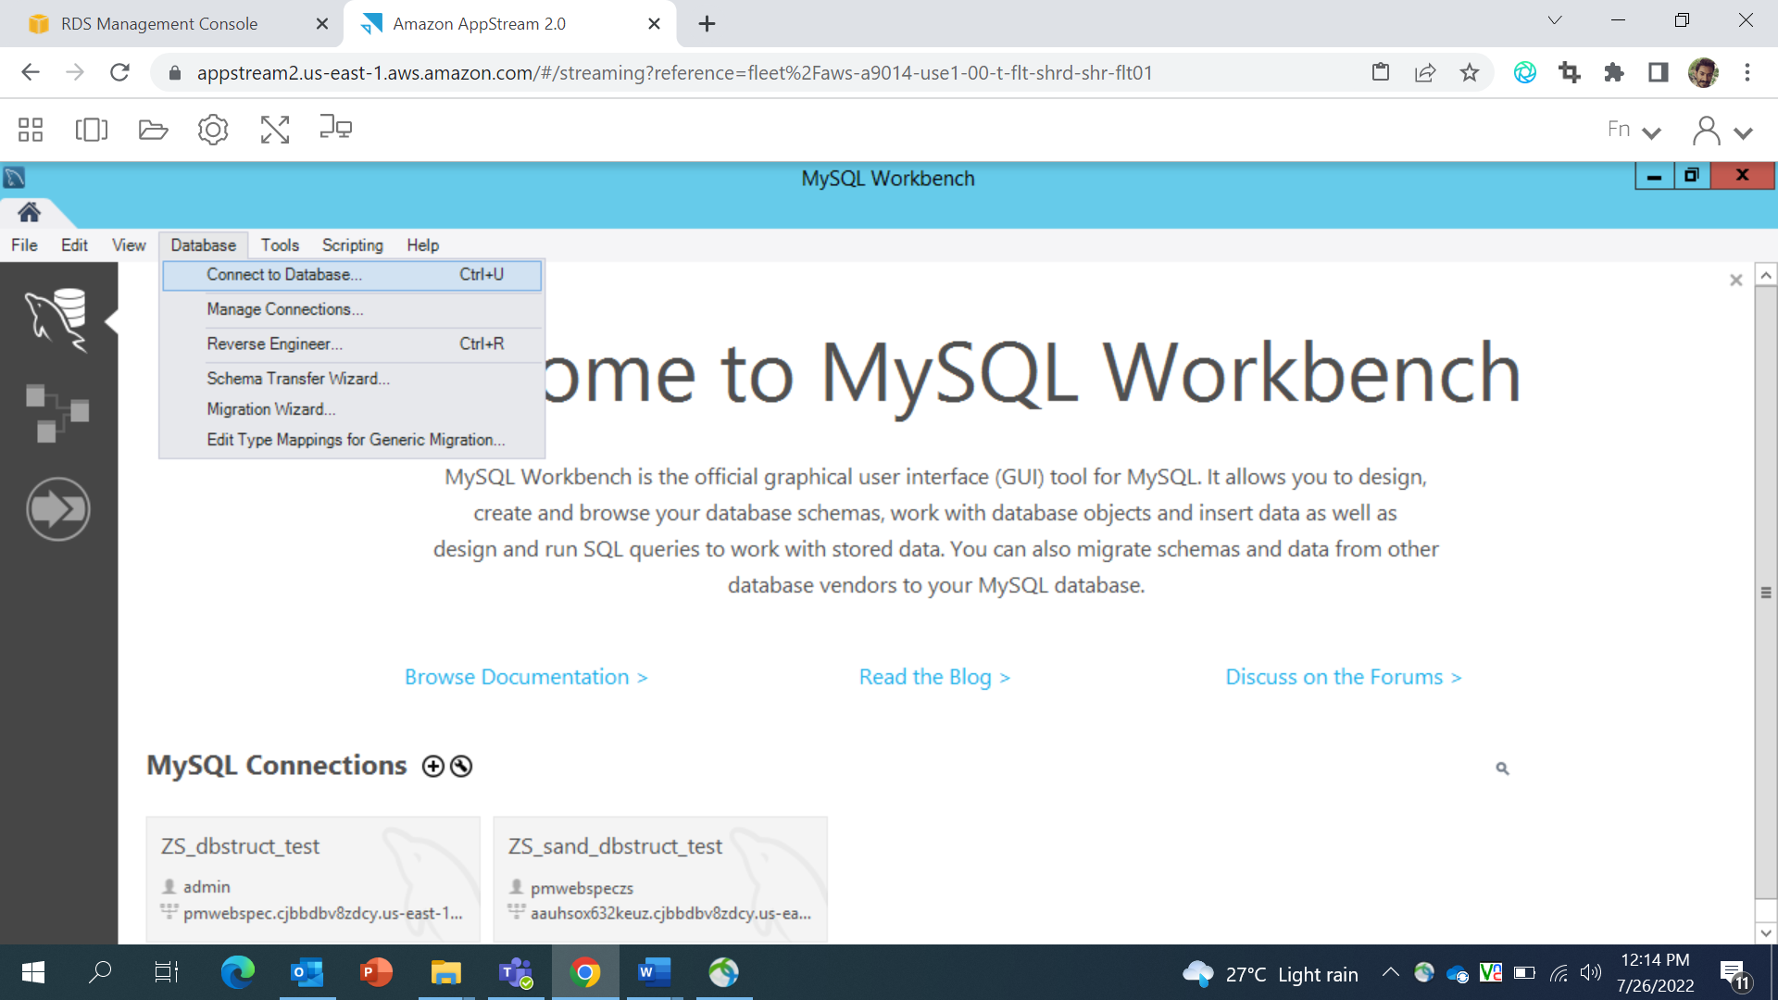
4. From new popup window select stored connection and select we have created one i.e ZS_ST_Migration 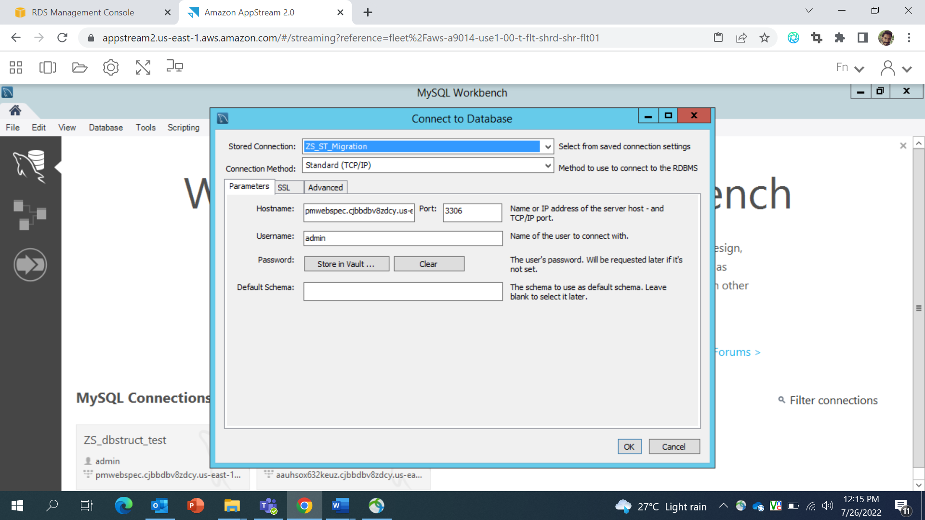
5. You will redirect to the database details page. 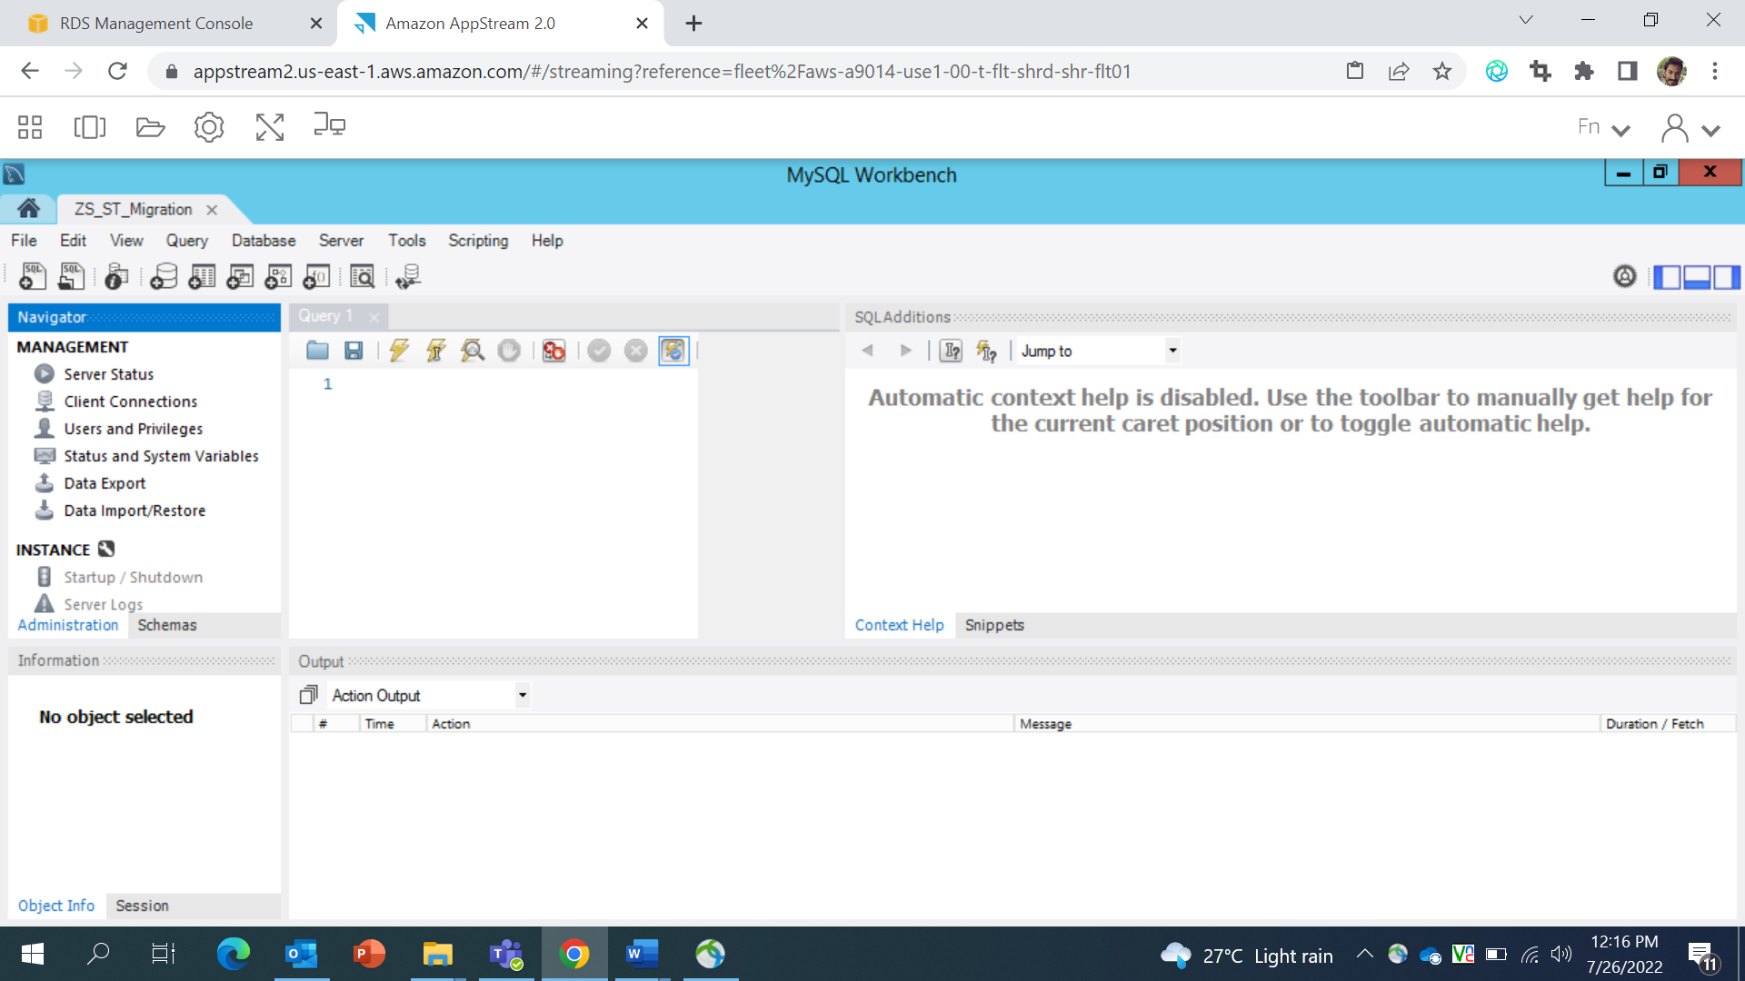
6. Click on “Schema” under the instance. 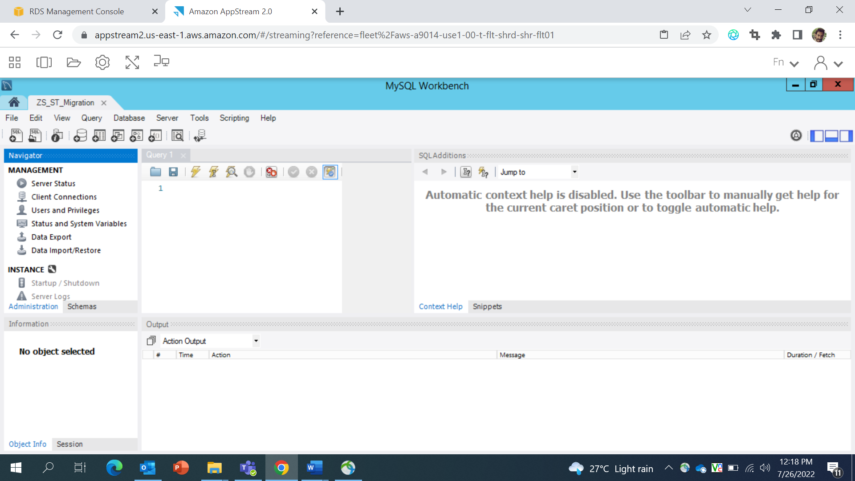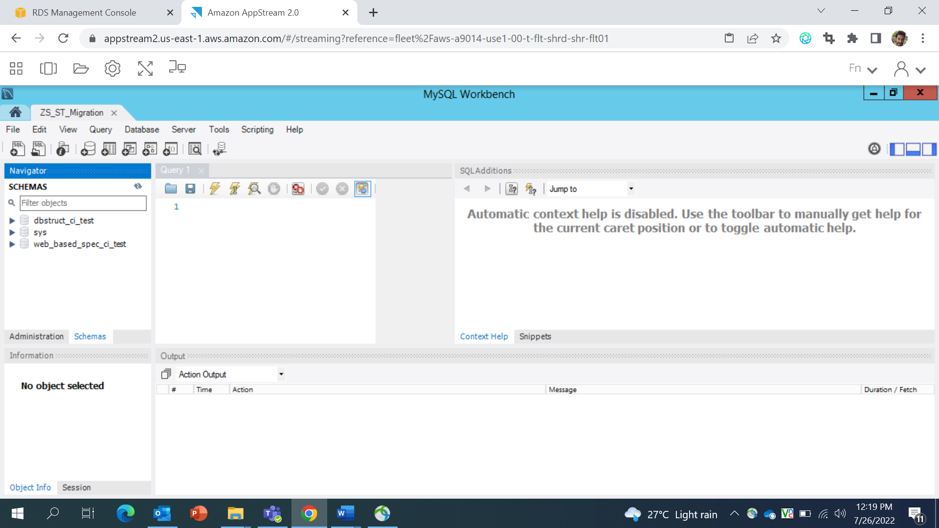
7. Click on “**database** **icon**” below Query navigation bar from the top.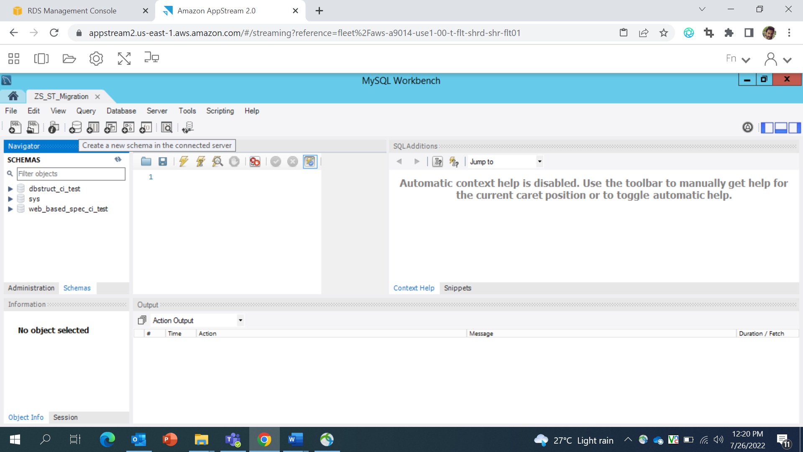 Enter The Database name i.e dbstrct_ci_test in Name section and click on “Apply” Button. 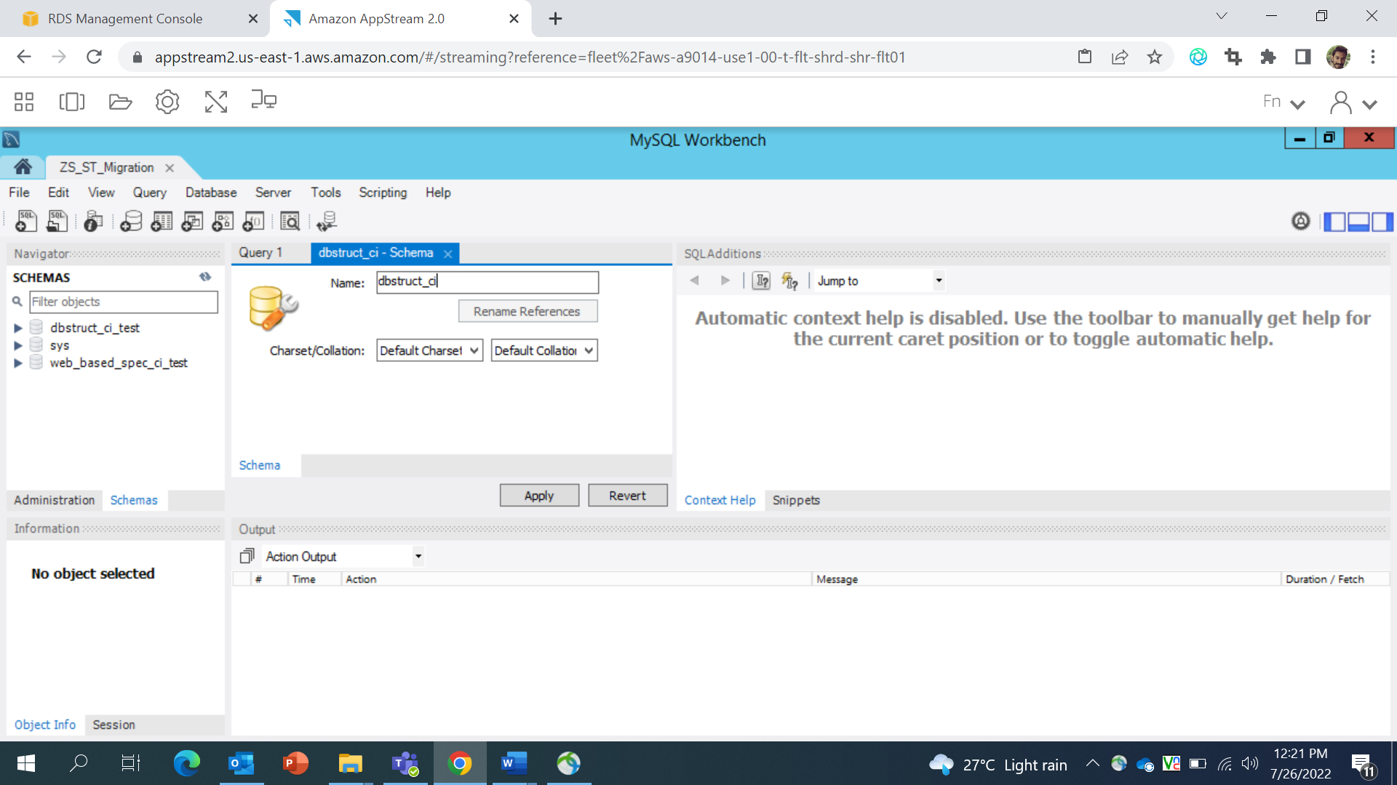 Click to “**Apply**” button redirect you to the SQL pre execution window just click on “**Apply**” button to execute script. 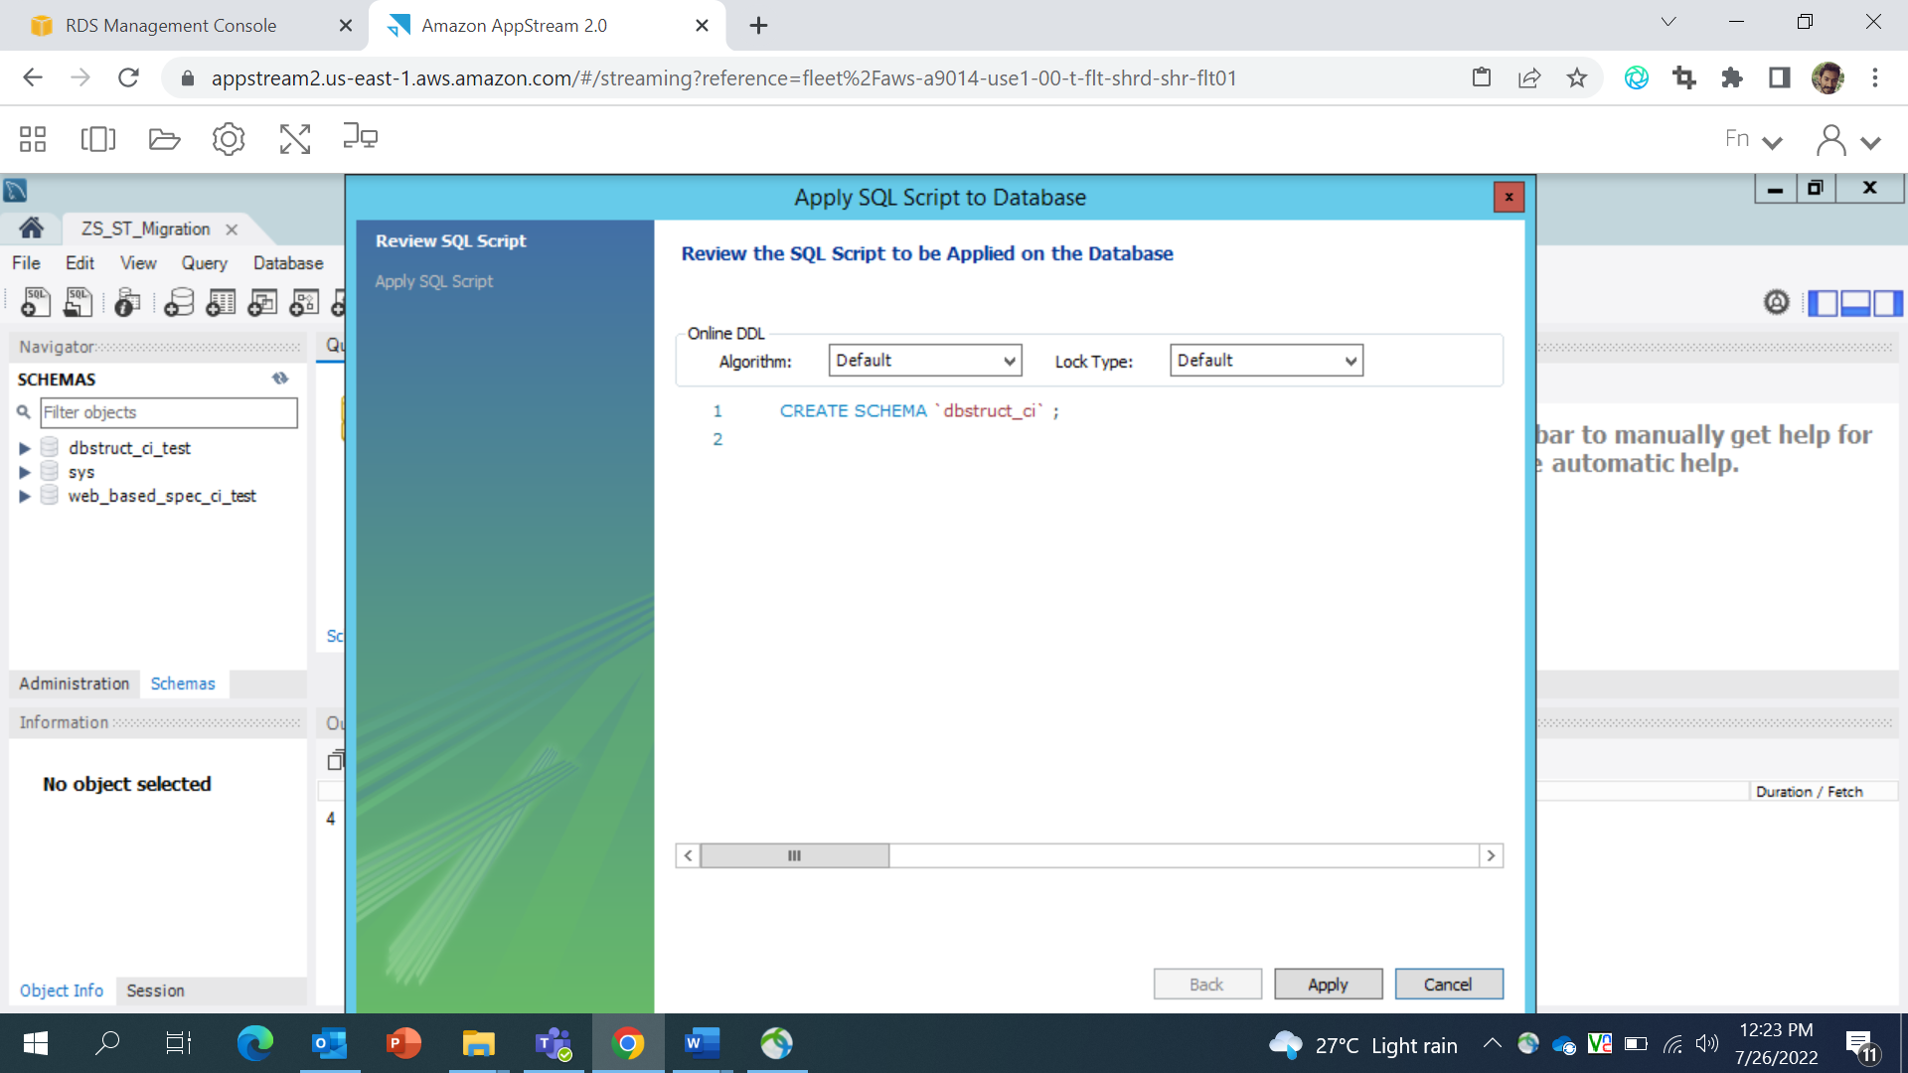 After executing script you will redirect to the final window i.e finish script just click on “**finish**” button to finish execution of script. 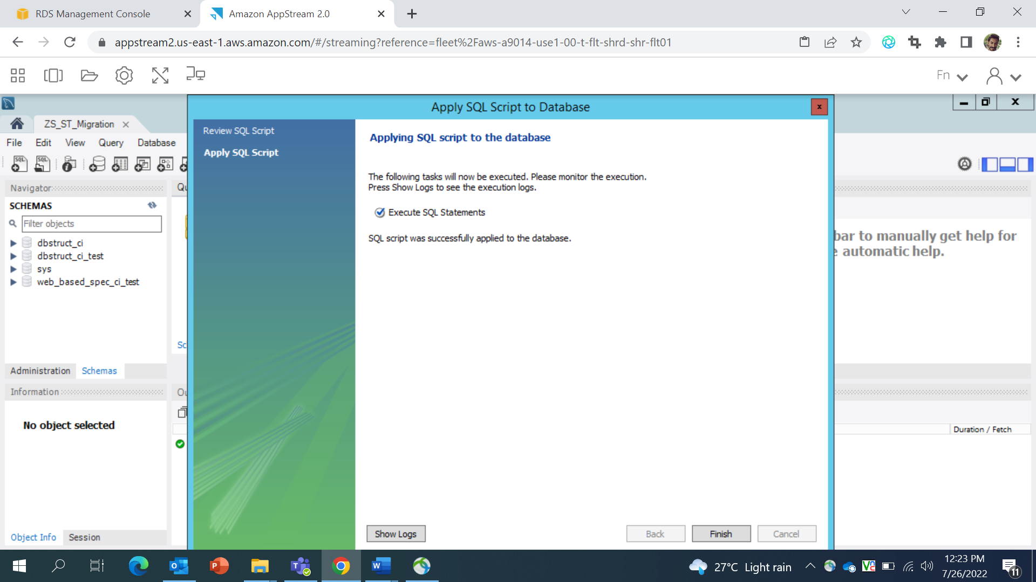
8. For migrating “web_based_spec_ci_test” database please refer **Step 11**. Added few Screen for creating database. 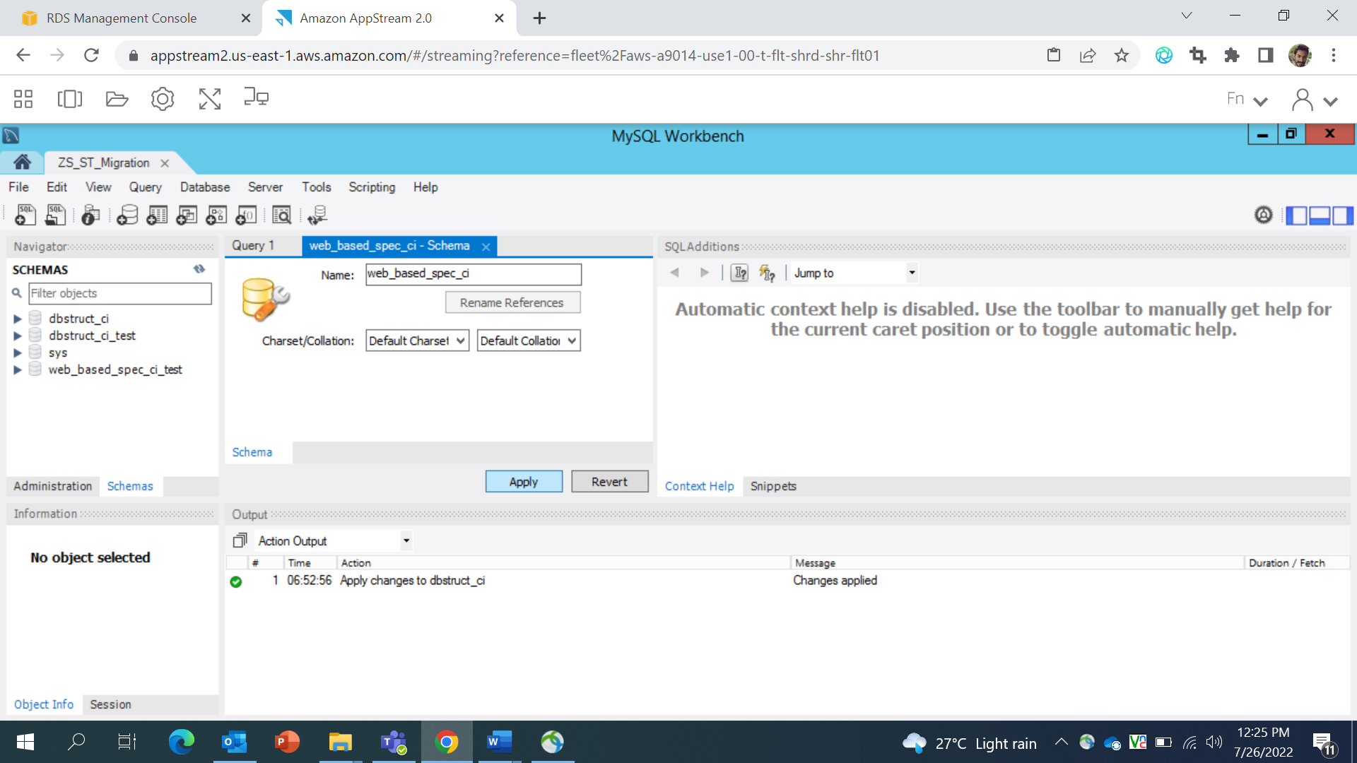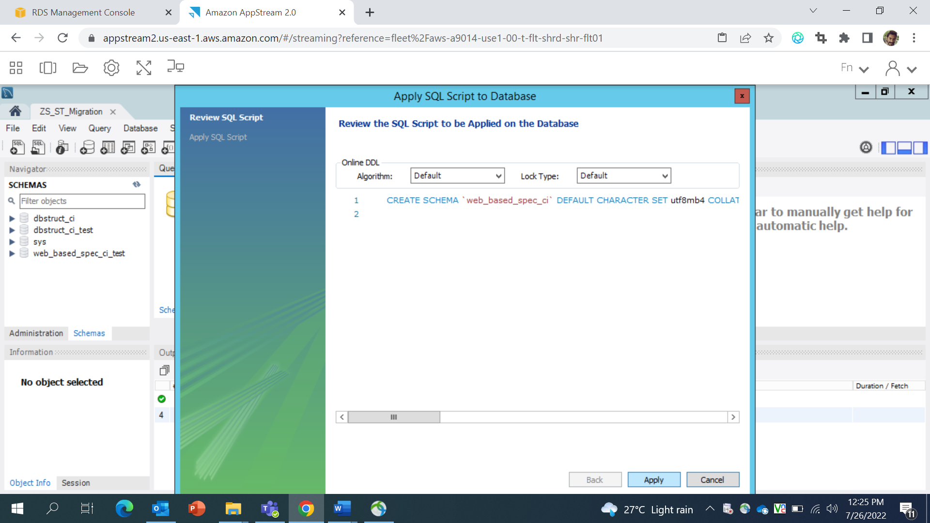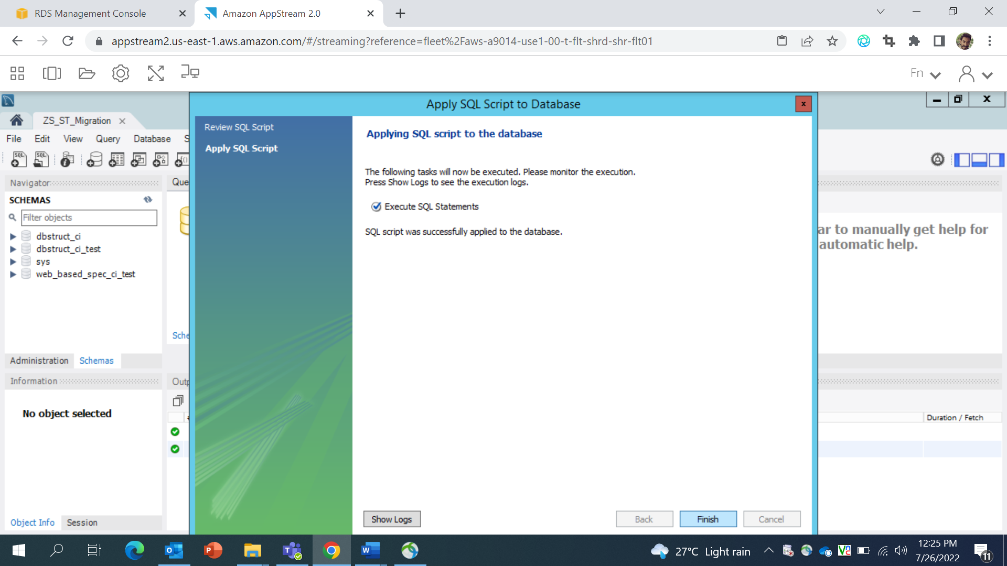
9. From the left site-minder just right click on “**dbstruct_ci_test**” database and click on “**set as default schema”** 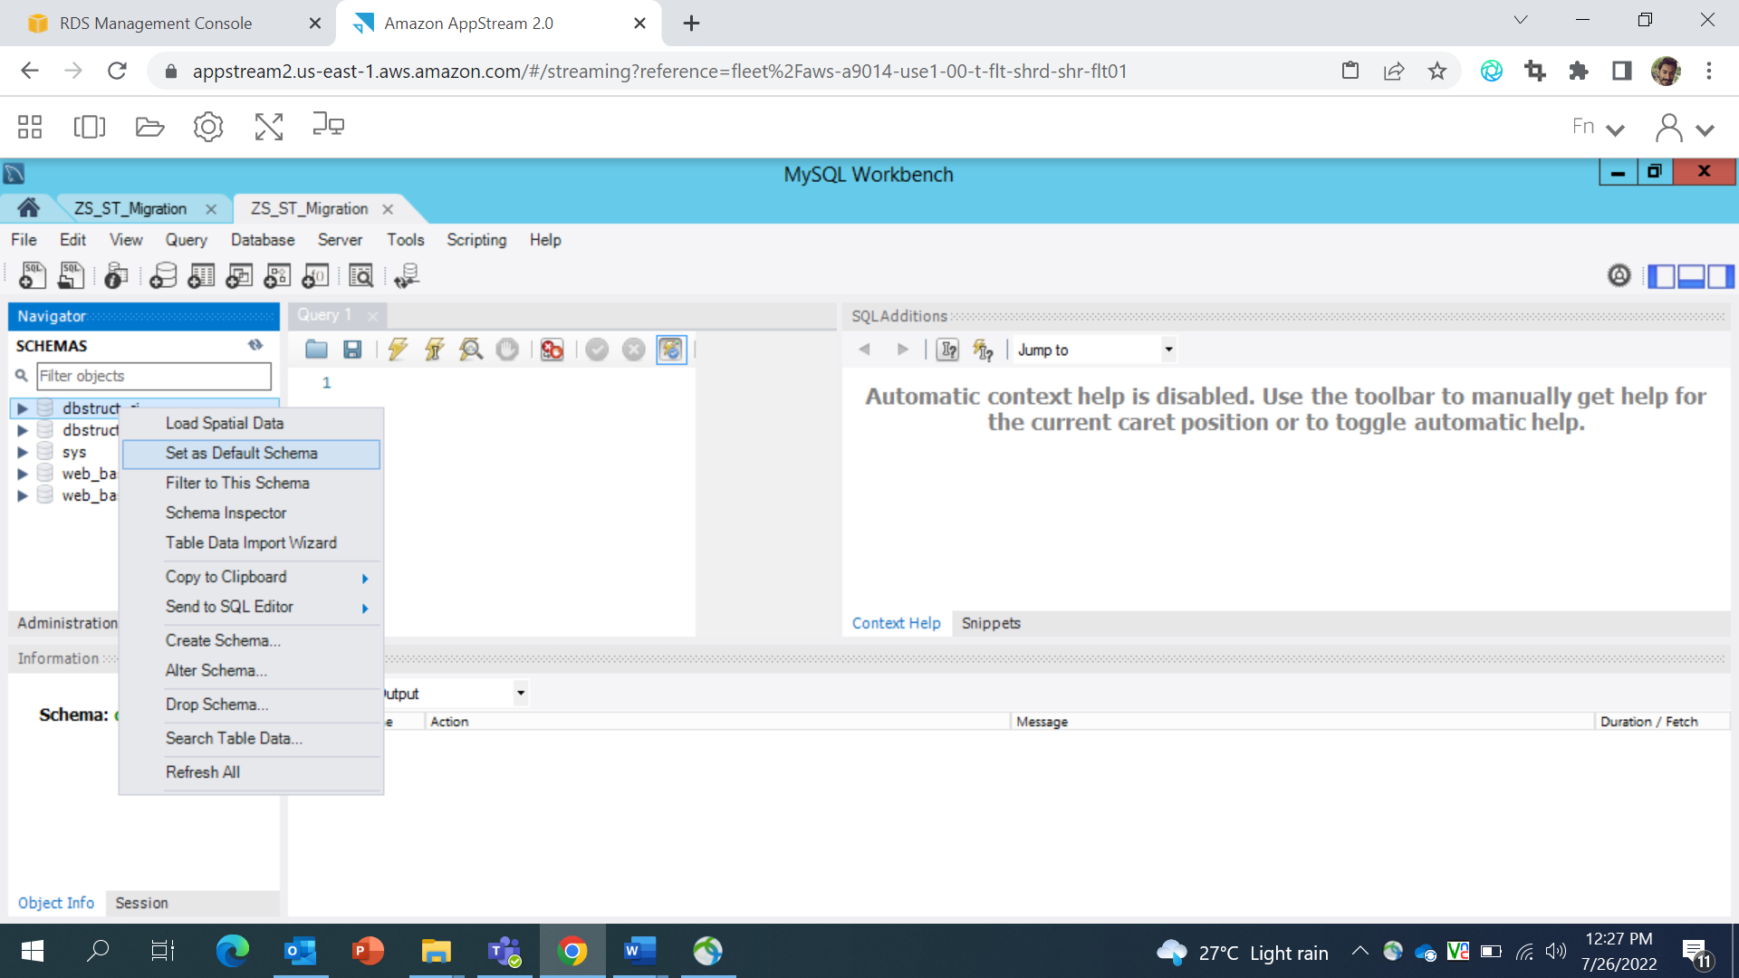
10. Copy the sql code from GIT location(**https://github.com/BMS-CPP/PmWebSpec_Test/blob/main/Database/dbstruct_ci_test.sql**) as per selected database select dbstruct_ci_test.sql file and select all the sql queries from selected file and paste it to in sql query window. 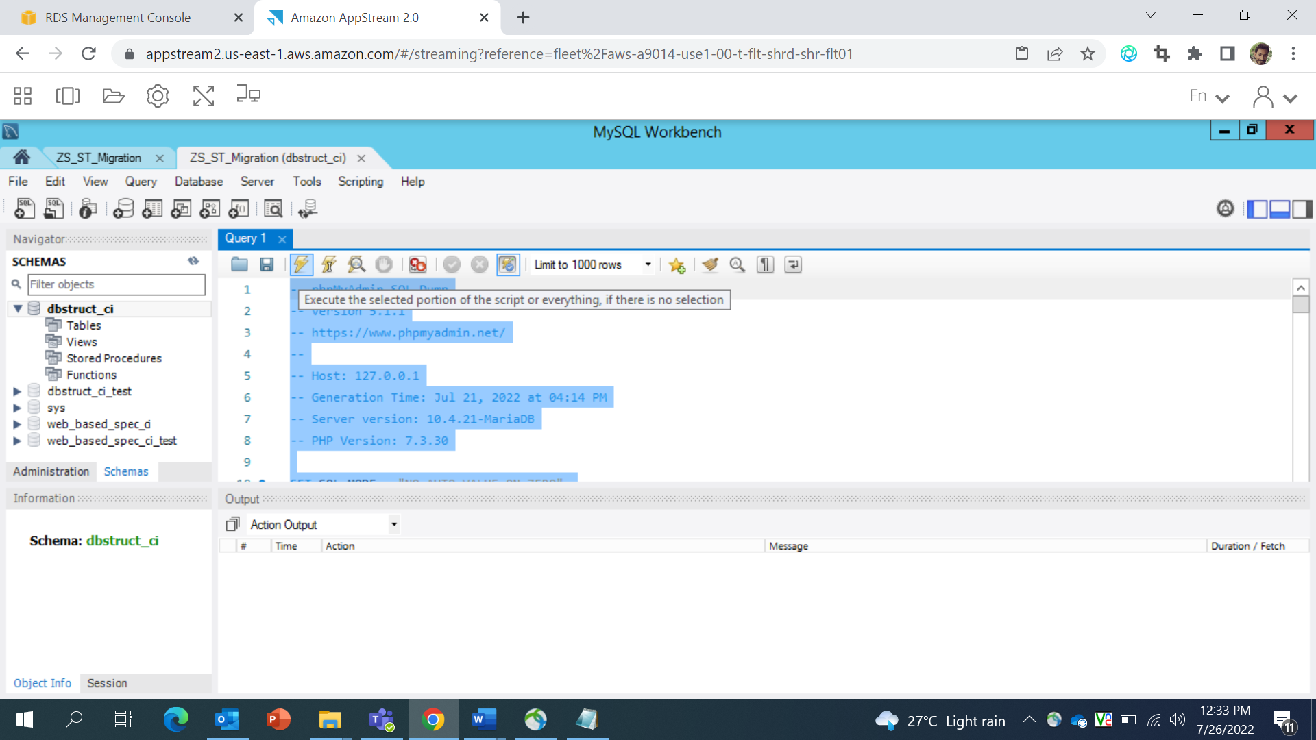
11. just click on RUN icon – to run all the scripts. 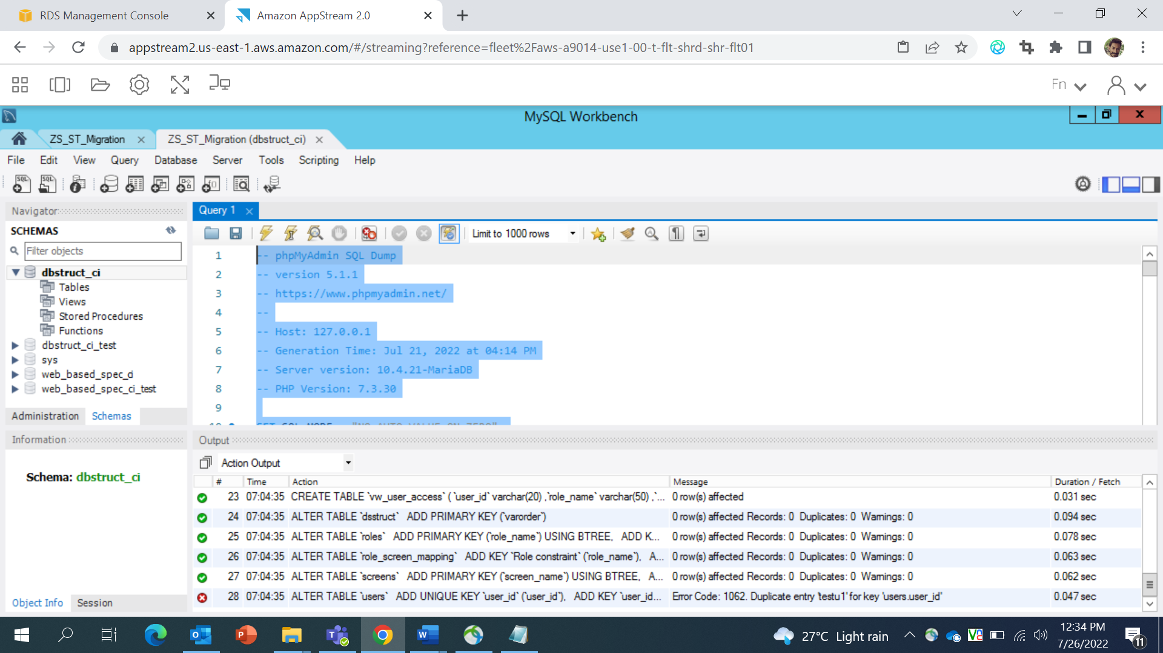
12. right click on selected database and refresh all the database you can see all the tables from the database. 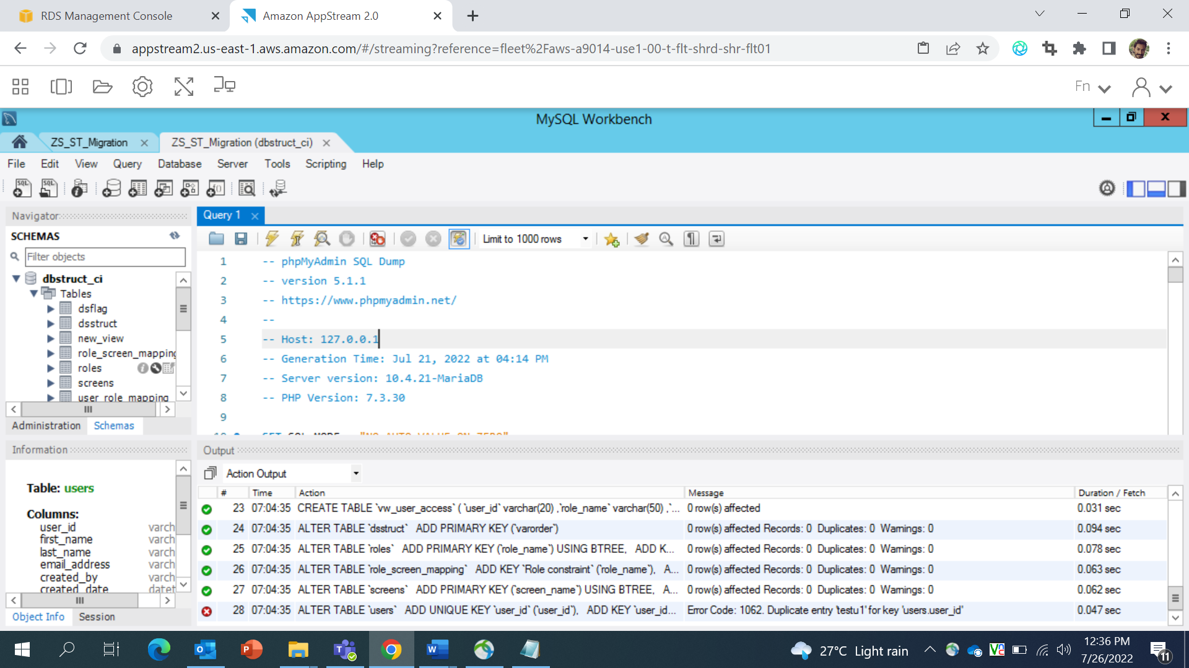
13. Refer Steps 13,14,15,16 for importing “**web_based_spec_ci_test**” database. 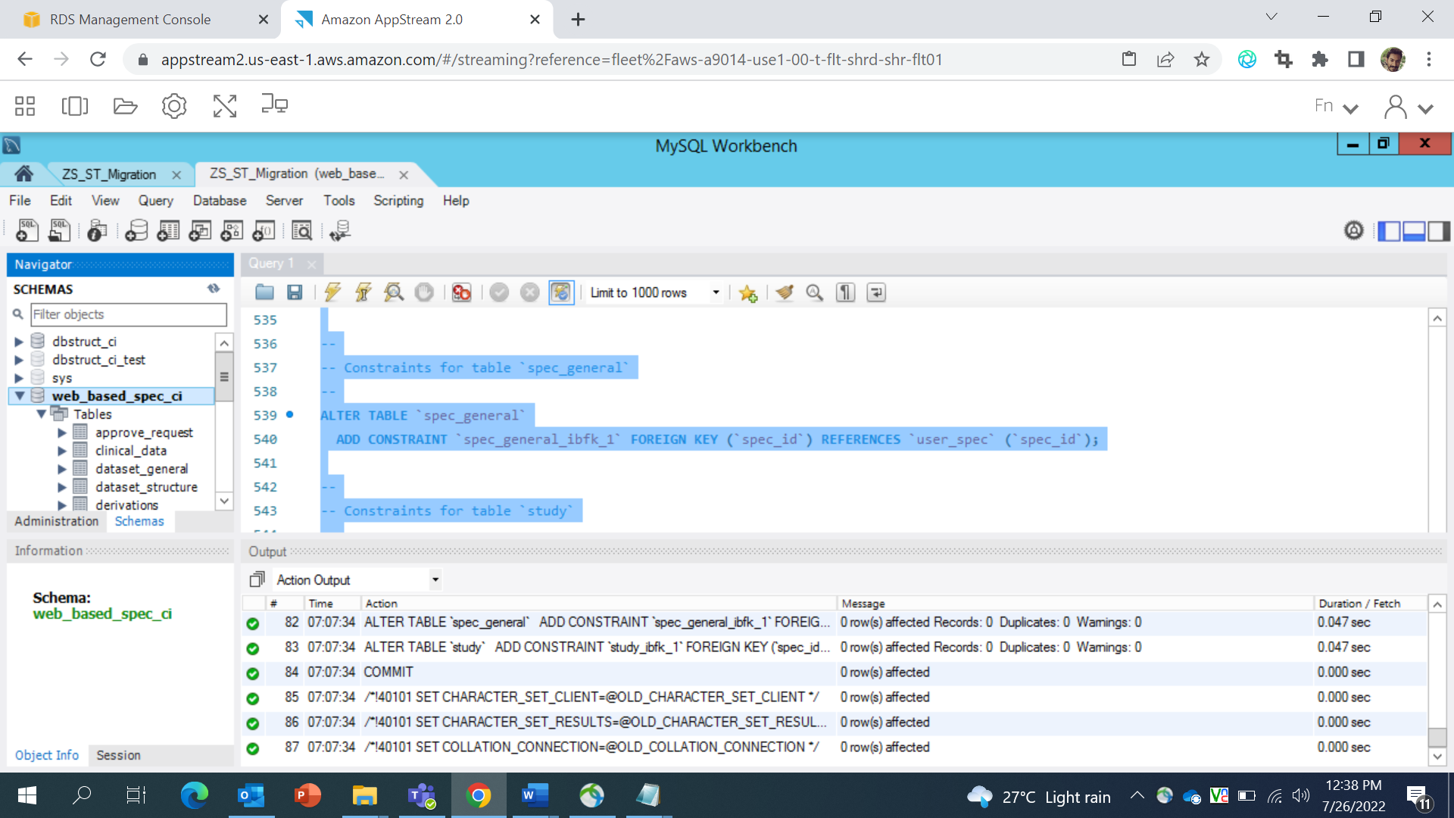
14. Open **https://github.com/BMS-CPP/PmWebSpec_Test/blob/main/PmWebSpec_dev/pframe/config/config.php** file to update base url.

**$config['base_url'] = “Enter the application url”; on line 33.**

1. Open **https://github.com/BMS-CPP/PmWebSpec_Test/blob/main/PmWebSpec_dev/pframe/config/database.php** file to update hostname, username, password and database.

Note: We need to update it for both the databases.

**Make the changes and save file, after saving change make a zip folder of application and deploy the stack.**

1. Open the application in browser it will show application home screen. 